Ulric Aird & Trevon Friday

Capstone Project

Design Phase

**Authentication Process**

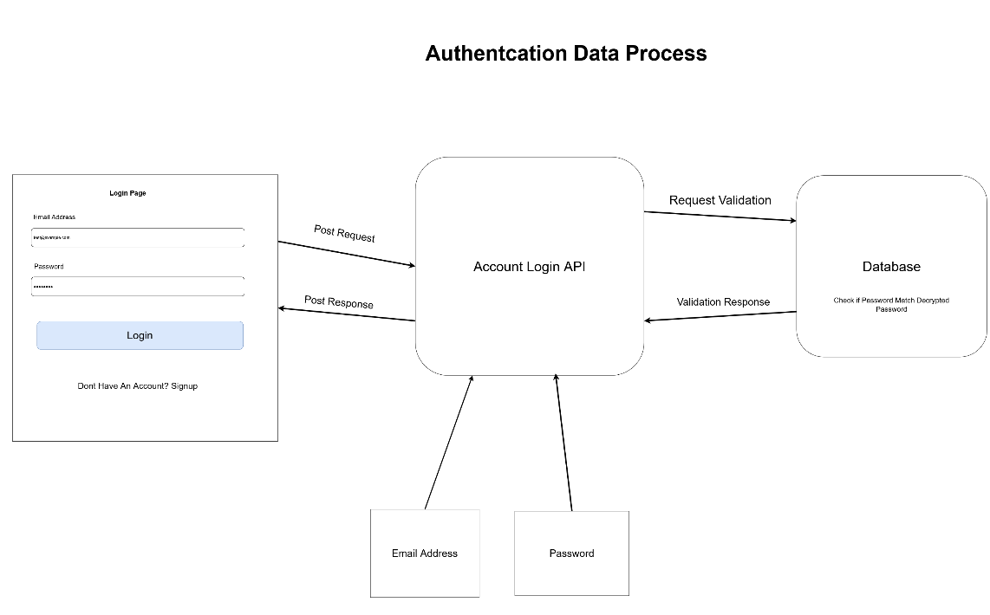This is DFD of how the User Authentication process works in the backend.

This is how the User Interface looks like to the user.

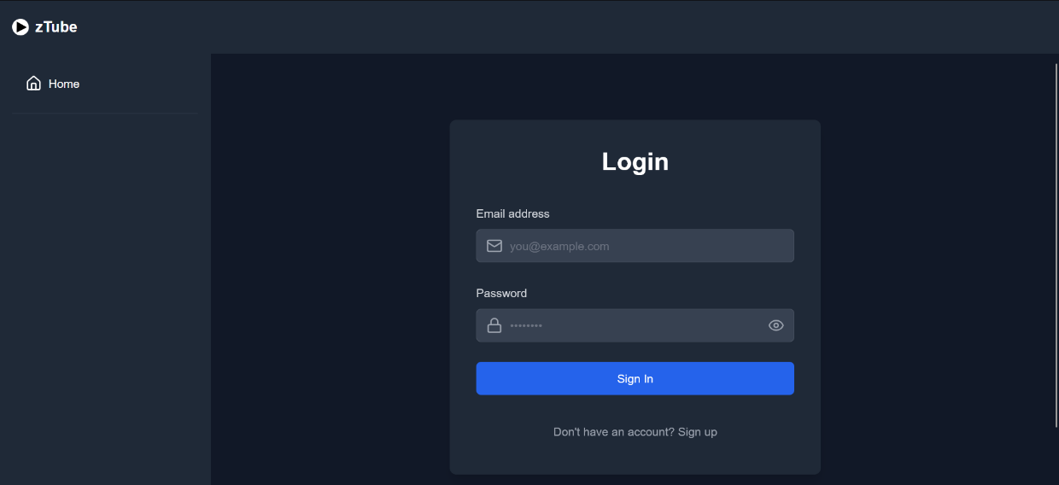

**Upload Process**

This is a DFD of how the video upload process should take place.

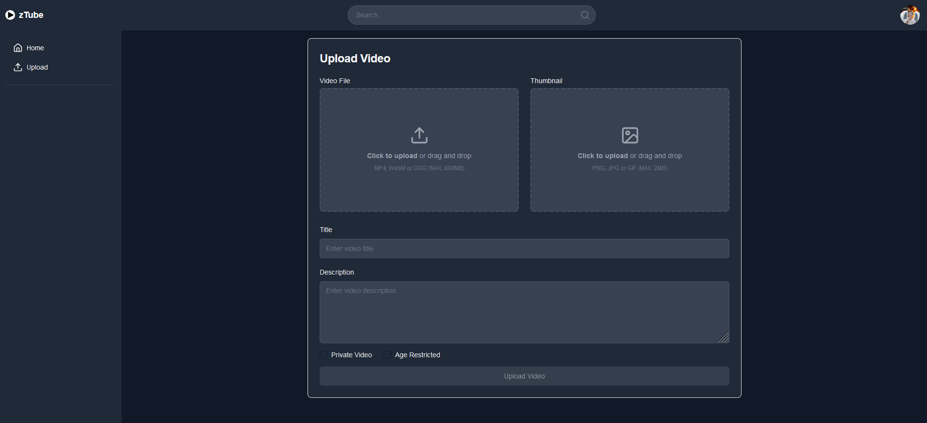This is the user interface the user will see when uploading a video to the platform.

**Video Display Process**

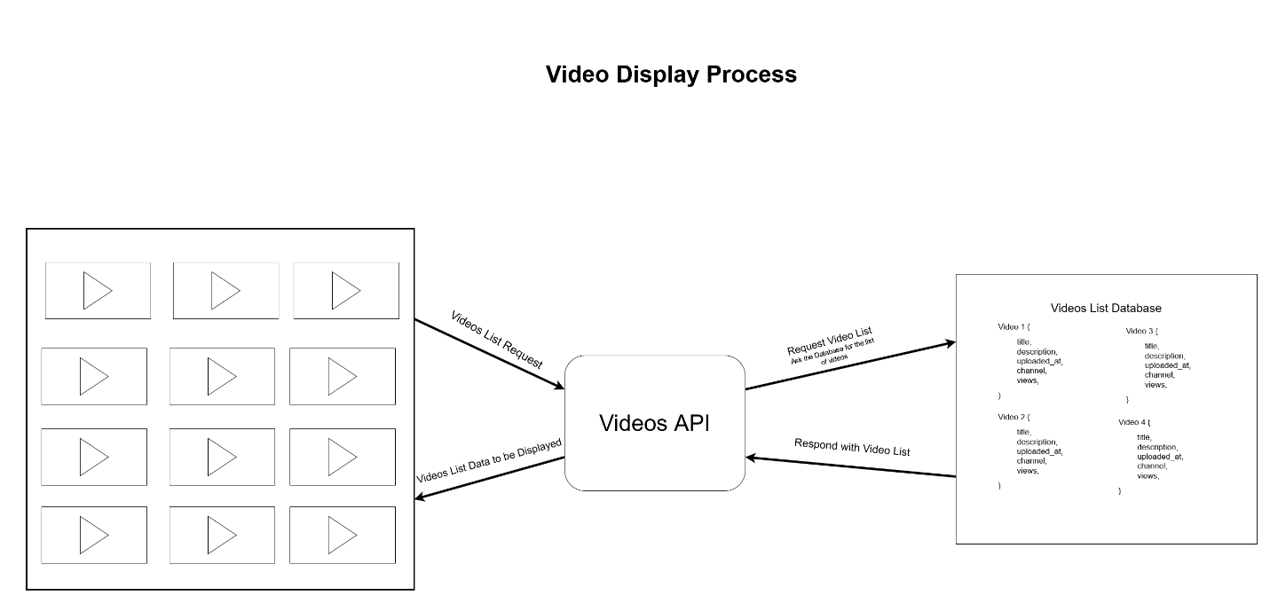This is a DFD how the videos are fetched and displayed to the user.

This is how the videos are displayed to the user on the front page. Don’t mind the thumbnails.

